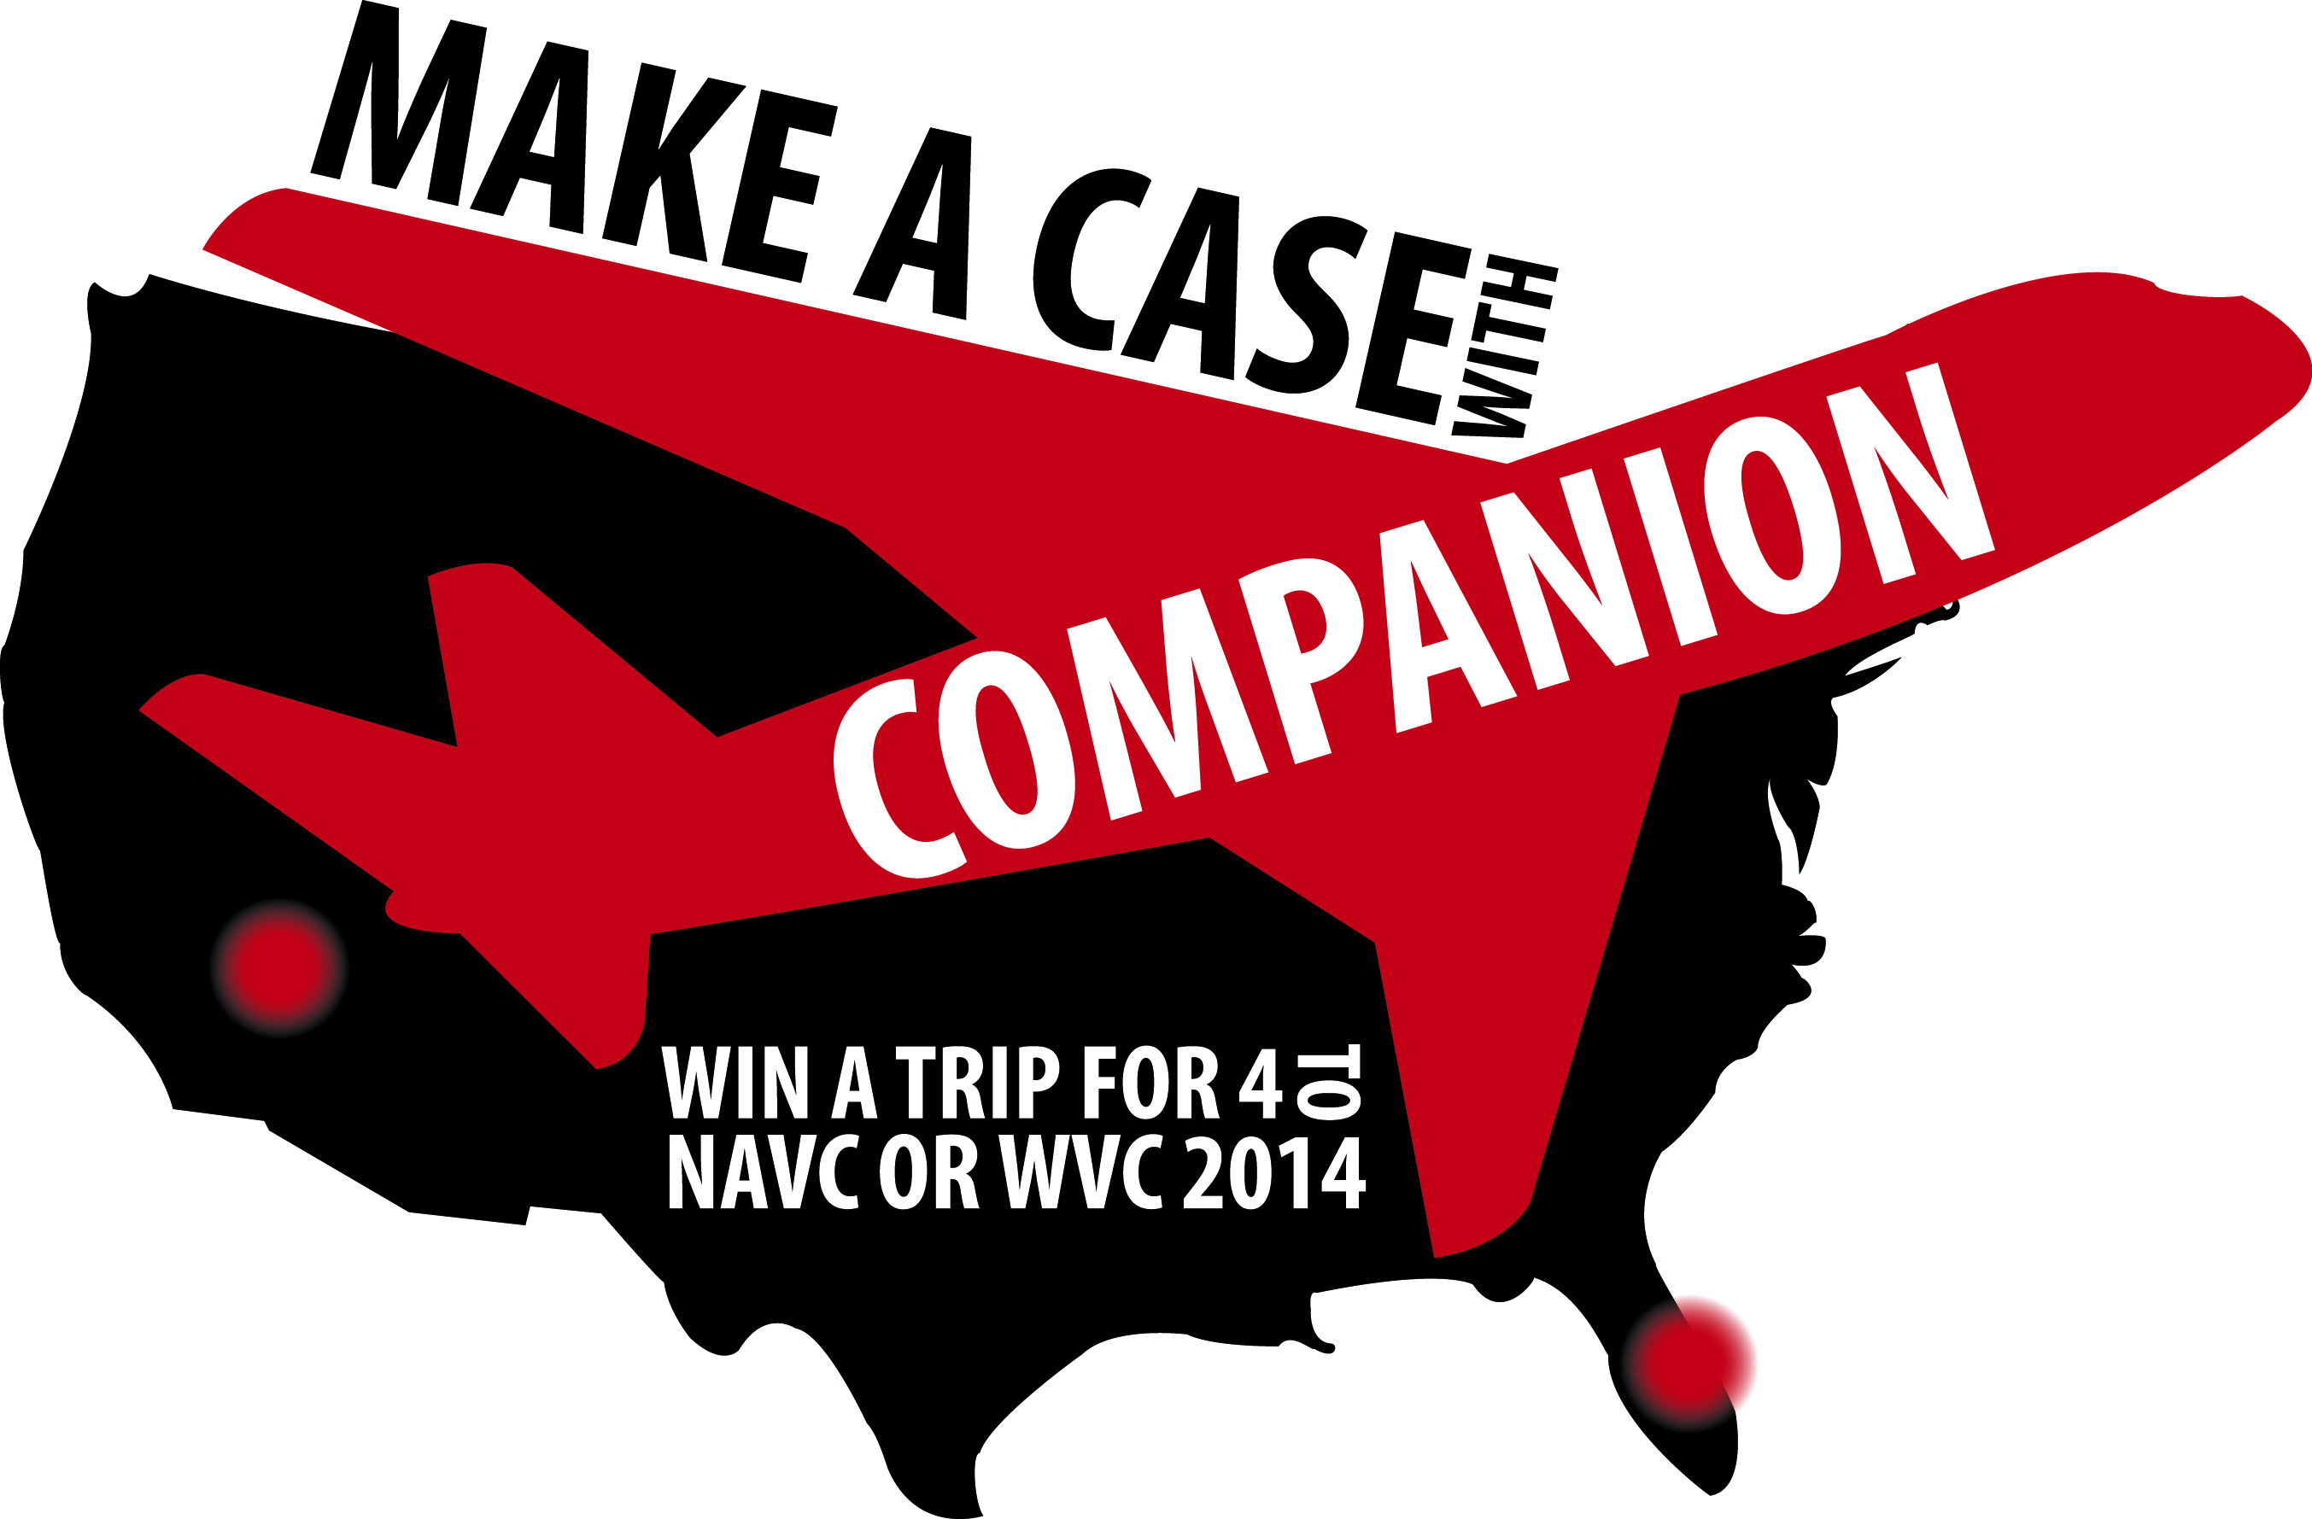

CASE SUBMISSION INFORMATION
Case Submission Contact | Type Your Name & Academic Degrees
Supervising Veterinarian | Type Your Supervising Veterinarian’s Name & Academic Degrees
Practice Name & Phone | Type Your Practice’s Name
Practice City & State | Type Your Practice’s City & State
Supporting Photos? | Are you providing photos with this case? Yes or No
Supporting Video? | Are you providing videos with this case? Yes or No

PATIENT INFORMATION
Patient Name | Type Name
Patient Age & Gender | Type Age & Gender
Species and Breed | Type Species & Breed
Patient’s Symptoms | Include location and associated symptoms
Medical History | Include current and past diagnoses, medications, etc.
Initial Assessments | Type results of any initial tests
Initial Diagnosis | Type Initial diagnosis

IMPORTANT TIP!
Be sure to take photos or video of pre-, intra-, post-, and follow-up images. Take photos and videos on mobile devices, tablets, or with digital cameras. See submission guidelines for details about how to submit this media along with your case.

Email Completed Case to amandac@litecure.com
TREATMENT INFORMATION
Laser Make & Model | Type the laser make & model used for treatments
Frequency of Treatment | Enter how often treatments were applied and time between treatments
Protocol Used | Enter Built-In protocol used and/or patient characteristics (skin color, body type)
Mode | Enter CW or frequency (Hz) used to administer treatment
Power | Enter power setting in Watts (W)
Treatment Time | Click here to enter duration(s) of each laser treatment session
Total Energy Delivered (= Power x Time) | Enter total energy (Joules) delivered during treatment
Areas Treated | Enter body part locations of treatment
Approximate Size of Area Treated (in cm²) | Enter the size of the area treated in cm²
Other Treatment Details | Enter details about the treatment head used and the distance held from the skin
Any Other Treatments Used | Enter any other treatment techniques, approaches or protocols used
Assessment Used | Enter assessments, functional and quantitative measures are best
RESULTS
Discuss patient response to treatment. Explain any correlations or inconsistencies. Include or attach images, tables, graphs, etc.
Type results here
DISCUSSION
Include information/ applicability to other conditions if appropriate.
Type discussion here
REFERENCES
Include information/ applicability to other conditions if appropriate.
Type references here
HOW TO SUBMIT YOUR CASE STUDY
For Case Studies with Videos: Please visit http://www.wetransfer.com, select the video AND written case study files you wish to send and send to amandac@litecure.com. In the message simply type, “Make a Case With Companion Contest”. You will receive an e-mail confirmation that your submission has been received.

For Case Studies without Videos: Please e-mail photos AND written case study files to amandac@litecure.com. You will receive an e-mail confirmation that your submission has been received.

Submitting by Mail: Mail printed case study submissions and CDs and USBs with videos and photos to:
LiteCure
Attn: Amanda Capitanio
250 Corporate Blvd, Suite B
Newark, DE 19702
USBs and CDs will not be returned so please be sure only relevant case study information is sent.

Please name your file “Your Name_Practice Name”, i.e. “John Smith_ All Creatures Pet Clinic”. In your email confirmation will be all of the final contest details including the date of winner announcement.

RULES & REGULATIONS
- Practices may submit as many different case studies as they wish; all entries will be valid and considered independently of one another.
- Entries received after November 15, 2013 will not be considered.
- Please be sure photos and videos submitted depict all clients, staff, and when applicable, patients, wearing laser-safe eyewear.
- The supervising veterinarian whose name is on the case report entry form will be awarded the trip and is responsible for providing Companion with the names of the 4 practice members who will attend the trip and the conference of their choice (NAVC or WVC) by November 30, 2013.

By submitting a case study you give Companion Therapy Laser the right to use your study and supporting photos and videos for general marketing and educational purposes including but not limited to reproduction in the veterinary press, on CompanionTherapy.com, and in Companion advertisements and Companion social media channels.

The supervising veterinarian who submits the most compelling laser therapy case will be named the winner of the Make a Case With Companion Contest and will be awarded tuition and travel for 4 practice members to their choice of NAVC or WVC 2014. Companion Therapy Laser will pay for round trip airfare for 4 individuals from the practice and will also provide 4 nights of accommodations for each of the individuals from the practice attending the conference (16 total room nights).

